**ENTITY RELATIONSHIP DIAGRAM**

• 1. Entity Relationship Diagram (ERD)

• 2. Objectives:

Describe the entity modeling process. Discuss how to draw an entity relationship diagram. Describe how to recognize entities, attributes, relationships, and cardinalities.

• 3. Database Model:

A database can be modeled as: a collection of entities, relationship among entities. Database systems are often modeled using an Entity Relationship (ER) diagram as the “blueprint” from which the actual data is stored — the output of the design phase.

• 4. Entity Relationship Diagram (ERD):

ER model allows us to sketch database designs. ERD is a graphical tool for modeling data. ERD is widely used in database design ERD is a graphical representation of the logical structure of a database ERD is a model that identifies the concepts or entities that exist in a system and the relationships between those entities

• 5. Purposes of ERD:

An ERD serves several purposes:

* The database analyst/designer gains a better understanding of the information to be contained in the database through the process of constructing the ERD.
* The ERD serves as a documentation tool.
* Finally, the ERD is used to communicate the logical structure of the database to users.
* In particular, the ERD effectively communicates the logic of the database to users.

• 6. Components of an ERD:

An ERD typically consists of four different graphical components:

1. Entity
2. Relationship
3. Cardinality
4. Attribute

• 7. Classification of Relationship Optional Relationship:

An Employee may or may not be assigned to a Department A Patient may or may not be assigned to a Bed.

Mandatory Relationship Every Course must be taught by at least one Teacher. Every mother have at least a Child

• 8. Cardinality Constraints:

Express the number of entities to which another entity can be associated via a relationship set. Cardinality Constraints - the number of instances of one entity that can or must be associated with each instance of another entity.

Minimum Cardinality: If zero, then optional. If one or more - then mandatory. Maximum Cardinality, The maximum number

• 9. Cardinality Constraints (Contd.):

For a relationship the cardinality must be one of the following types: One to one, A Manager Head one Department and vice versa One to many (or many to one), An Employee Works in one Department or One Department has many Employees. Many to many, Customers purchases many products or many products purchased by many customers. (But these relationships don’t work in a relational database so they would need a bridging entity which would then create a one - many relationship)

• 10. General Steps to create an ERD:

Identify the entity. Identify the entity's attributes. Identify the Primary Keys. Identify the relation between entities. Identify the Cardinality constraint. Draw the ERD. Check the ERD

**Steps in building an ERD**

• 11. Developing an ERD The process has ten steps:

1. Identify Entities

2. Find Relationships

3. Draw Rough ERD

4. Fill in Cardinality

5. Define Primary Keys

6. Draw Key-Based ERD

7. Identify Attributes

8. Map Attributes

9. Draw fully attributed ERD

10. Check Results

• 12. A Simple Example:

A company has several departments. Each department has a supervisor and at least one employee. Employees must be assigned to at least one, but possibly more departments. At least one employee is assigned to a project, but an employee may be on vacation and not assigned to any project. The important data fields are the names of the departments, projects, supervisors and employees, as well as the supervisor and employee number and a unique project number.

• 13. Identify entities:

One approach to this is to work through the information and highlight those words which you think correspond to entities. A **company** has several **departments**. Each department has a **supervisor** and at least one **employee**. Employees must be assigned to at least one, but possibly more departments. At least one employee is assigned to a **project**, but an employee may be on vacation and not assigned to any project. The important data fields are the names of the departments, projects, supervisors and employees, as well as the supervisor and employee number and a unique project number. A true entity should have more than one instance.

Entity Type - is any type of object that we wish to store data about.

An instance – is a single occurrence of an entity type.

• 14. Find Relationships:

Aim is to identify the associations, the connections between pairs of entities. A simple approach to do this is using a relationship matrix (table) that has rows and columns for each of the identified entities.

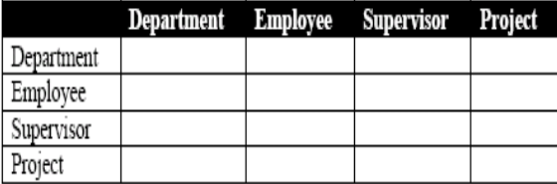 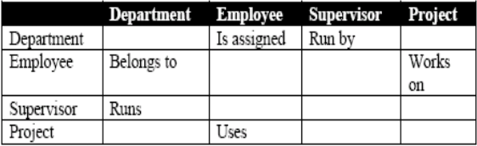

• 15. Find Relationships (Contd.) Go through each cell and decide whether or not there is an association. For example, the first cell on the second row is used to indicate if there is a relationship between the entity Employee and the entity Department.

• 16. Identified Relationships:

Names placed in the cells are meant to capture/describe the relationships. So you can use them like this:

* A Department is assigned an employee
* A Department is run by a supervisor
* An employee belongs to a department
* An employee works on a project
* A supervisor runs a department
* A project uses an employee

• 17. Draw Rough ERD:

Draw a diagram and:

* Place all the entities in rectangles
* Use diamonds and lines to represent the relationships between entities.

• 18. Fill in Cardinality:

**Supervisor** Each department has one supervisor.

**Department** Each supervisor has one department.

Each employee can belong to one or more departments - **Employee** Each department must have one or more employees

Each project must have one or more employees - **Project** Each employee can have 0 or more projects.

• 19. Fill in Cardinality (Contd.):

The cardinality of a relationship can only have the following values:

* One and only one
* One or more
* Zero or more
* Zero or one

• 20. Cardinality Notation:

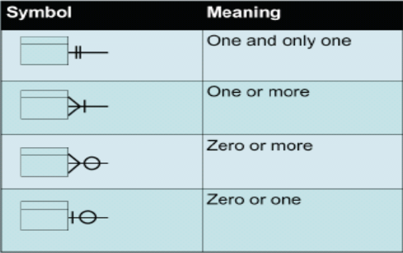

• 21. ERD with cardinality

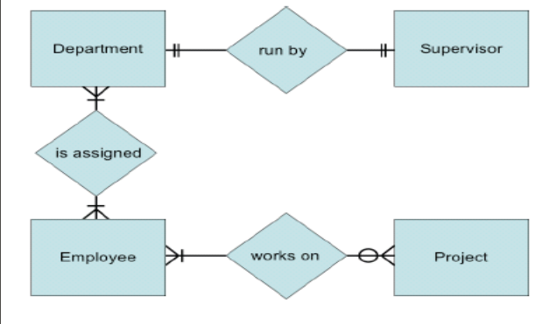

• 22. Rough ERD Plus Primary Keys

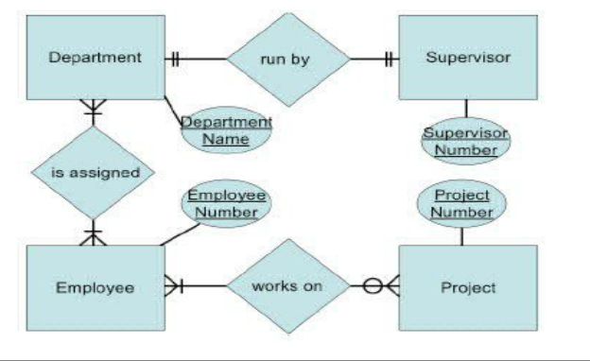

• 23. Identify Attributes:

In this step we try to identify and name all the attributes essential to the system we are studying without trying to match them to particular entities.

You should always verify these with your system users. (Sometimes forms, files and reports currently kept by the users of the system are useful.) The only attributes indicated are the names of the departments, projects, supervisors and employees, as well as the supervisor and employee NUMBER and a unique project number.

• 24. Map Attributes:

For each attribute we need to match it with exactly one entity. Often it seems like an attribute should go with more than one entity (e.g. Name). In this case you need to add a modifier to the attribute name to make it unique (e.g. Customer Name, Employee Name, etc.) or determine which entity an attribute best describes. If you have attributes left over without corresponding entities, you may have missed an entity and its corresponding relationships. Identify these missed entities and add them to the relationship matrix.

• 25. Map Attributes (Contd.)

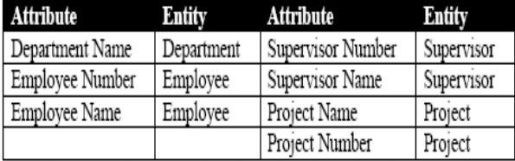

• 26. Draw Fully Attributed ERD

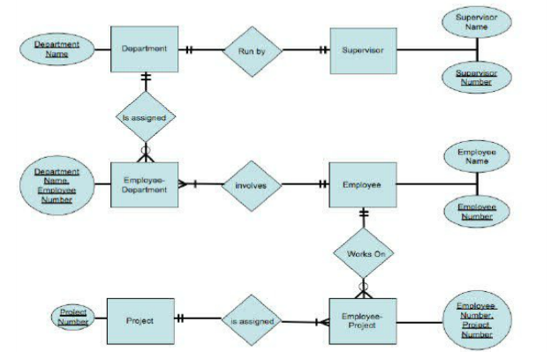

• 27. Check ERD Results:  
Look at your diagram from the point of view of a system owner or user. Is everything clear? Check through the Cardinality pairs. Also, look over the list of attributes associated with each entity to see if anything has been omitted.